MMA ([Mule-Migration-Assistant](https://github.com/mulesoft/mule-migration-assistant))

# Introduction:

Mule Migration Assistant is a command-line tool that helps migrate Mule 3.x applications to Mule 4.x. This tool works on a "best-effort" basis to translate every component in the base application. This means that if it does not complete 100% of the migration, manual adjustments are required. A migration report generated when the assistant is ran can help with those adjustments.

# Overview

In order to understand the tool, let's start with a couple of informal definitions:

* Task → a set of steps;
* Step → an operation that change/remove/update a resource or content that can be present in a project.

In simple terms, the tool executes a sequence of tasks over a project and outputs a migrated project and a report about the migration.

# Minimum requirements

* Java 8
* Maven 3.3.9

# Build and Run

See the following commands in order to clone, build and run this project

$ git clone --recursive git@github.com:mulesoft/mule-migration-tool.git

$ cd mule-migration-tool/

$ mvn clean package

$ cd runner/target

$ java -jar mule-migration-assistant-runner-*CURRENT VERSION*.jar [parameters]

#### Mule Migration Assistant accepted parameters

| **Parameter** | **Description** | **Required** |
| --- | --- | --- |
| projectBasePath | Path of the application to be migrated | Yes |
| destinationProjectBasePath | Path where to generate the migrated application | Yes |
| muleVersion | Mule 4 version to define on the application | Yes |
| parentDomainBasePath | Path of the domain to be migrated | No |
| help | Show all the parameters to define on MMA | No |

MMA migration process:

1. [Using the Mule Migration Assistant to Support Migration to Mule 4](https://github.com/mulesoft/mule-migration-assistant/blob/master/docs/user-docs/migration-tool.adoc)
2. [Perform a Migration to Mule 4](https://github.com/mulesoft/mule-migration-assistant/blob/master/docs/user-docs/migration-tool-procedure.adoc)
3. [Mule Migration Report](https://github.com/mulesoft/mule-migration-assistant/blob/master/docs/user-docs/migration-report.adoc)
4. [Post-Migration Tasks](https://github.com/mulesoft/mule-migration-assistant/blob/master/docs/user-docs/migration-tool-post-mig.adoc)

Steps to Execute MMA

Step1: Open command prompt and execute below commands

java -jar mule-migration-assistant-runner-*CURRENT VERSION*.jar

-muleVersion [Mule 4 Version]

-projectBasePath [mule 3 project directory]

-destinationProjectBasePath [Converted project location (Always specify a new path)]

Eg : java -jar mule-migration-assistant-runner-1.0.0.jar -muleVersion 4.2.0 -projectBasePath C:\Softwares\MMA\usflights -destinationProjectBasePath C:\Softwares\MMA\Demo

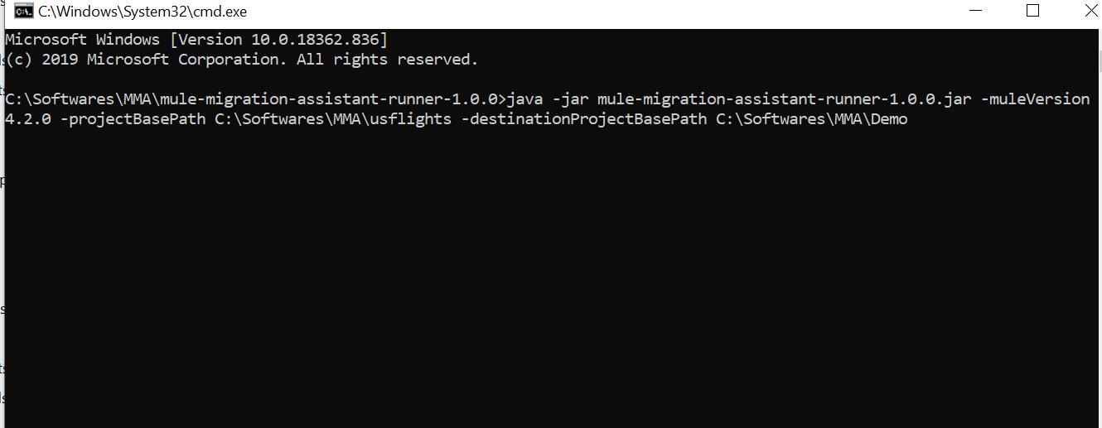

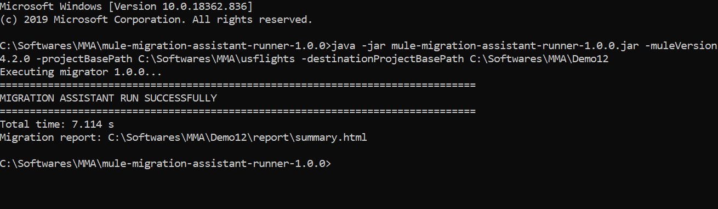

Step2:

Once you see MMA run success, open the folder of the destination project 🡪report 🡪summary

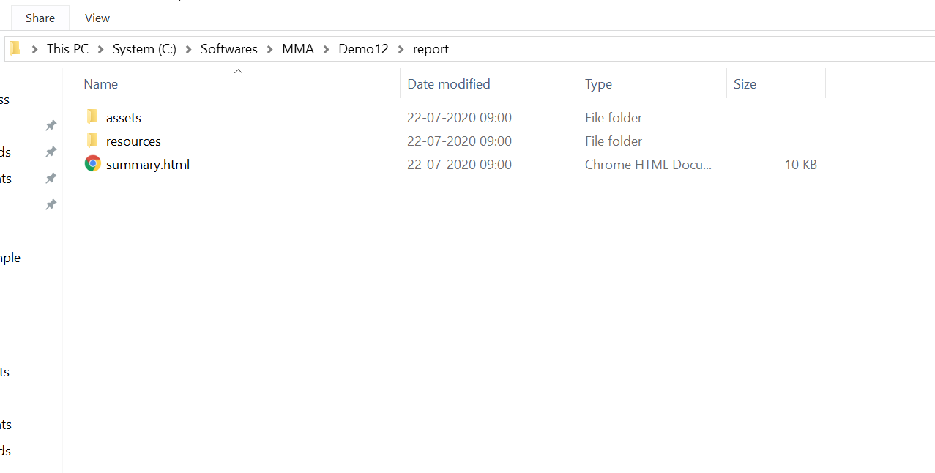

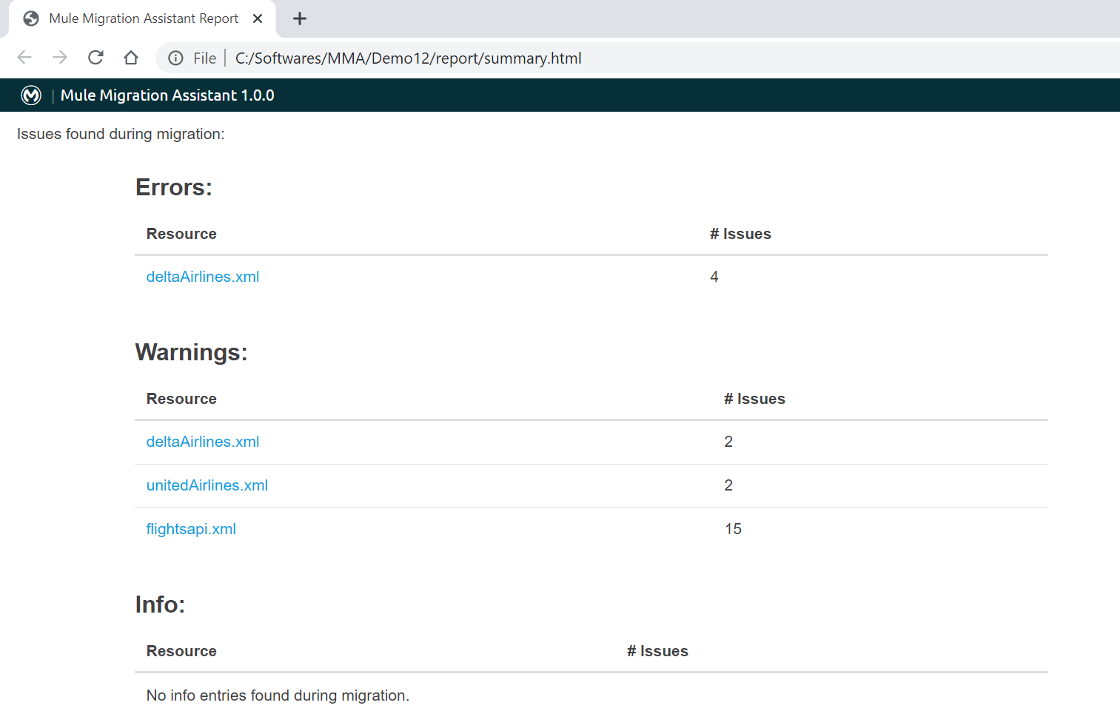

In the above slide we see Errors # 4

Try to analyse one by one and fix it in the migrated code (all details will be provided with documentation and reason of error)

Step 3:

Open Any point studio 7.x

Import the migrated code and make necessary changes as per the generated report and deploy.

Observations and Efforts:

* With MMA we can reduce 60 -70 % of development effort
* Time consumption on development will be reduced
* Only deprecated and few connectors are not supported where we need to change manually as per requirement
* Detailed report will be generated during migration which helps us to close errors during migration
* Code quality, Naming conventions and other detail will be maintained as per the old code
* All required files like pom.xml and atrifact.json will be generated automatically
* It will take less than one minute to run migration task
* [Lis](https://github.com/mulesoft/mule-migration-assistant/blob/master/docs/user-docs/migration-tool-procedure.adoc#migrating-unsupported-connectors)t of connectors not supported

# Use Cases:

## 1.Batch Flow:

## fpl-payments-bat

* We are trying to convert mule 3.9.4 project into mule 4.2.0
* Need mule 3 Project folder file system location.
* Command Executed:

java -jar mule-migration-assistant-runner-1.0.0.jar -muleVersion 4.2.0 -projectBasePath C:\Users\praveen\Desktop\Praveen\Mule3\fpl-payments-bat -destinationProjectBasePath C:\Users\praveen\Desktop\Praveen\Mule4.2\fpl-payments-bat

* Migrated projected will be saved to destinationProjectBasePath
* Navigate to migrated project location 🡪 report🡪 summary.html

PFB Screenshots for references:

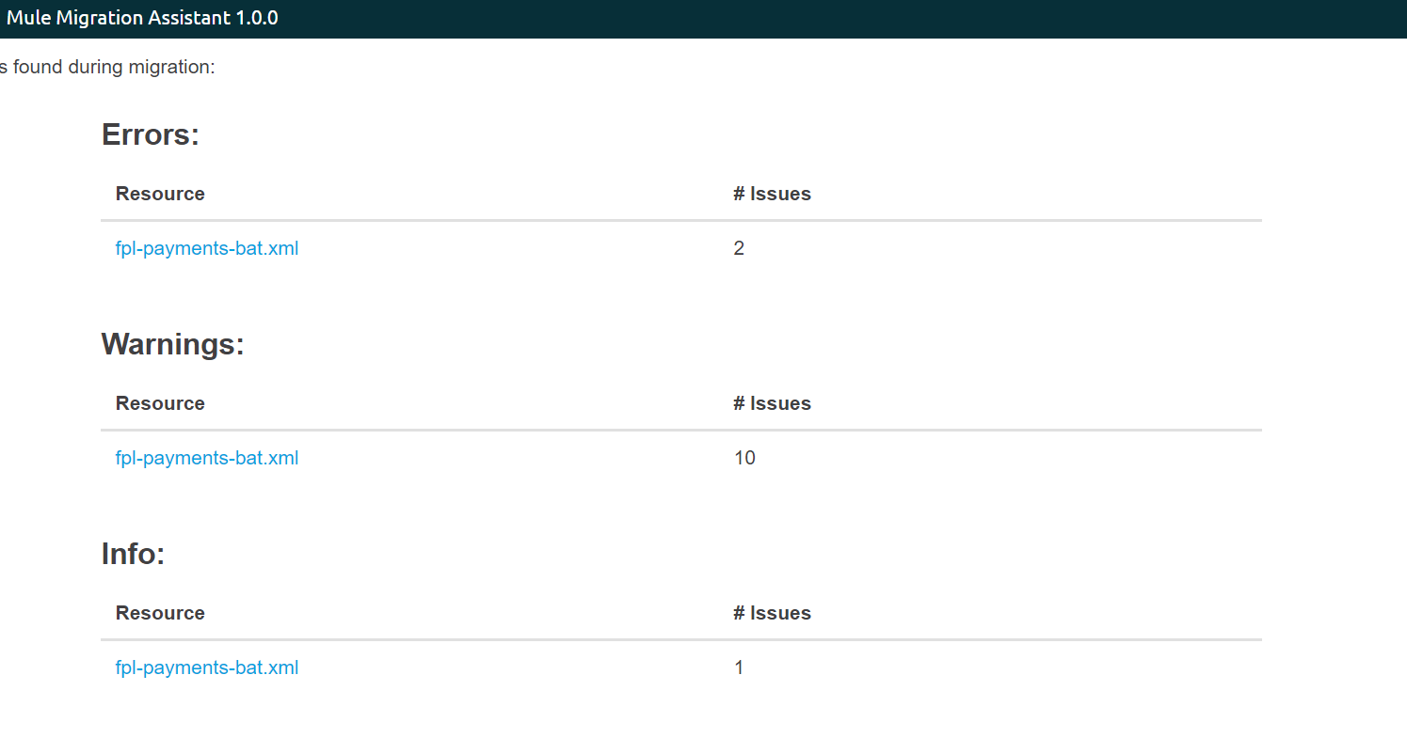

As per the error description in above html page 🡪Import the project to studio and make necessary adjustment in code .

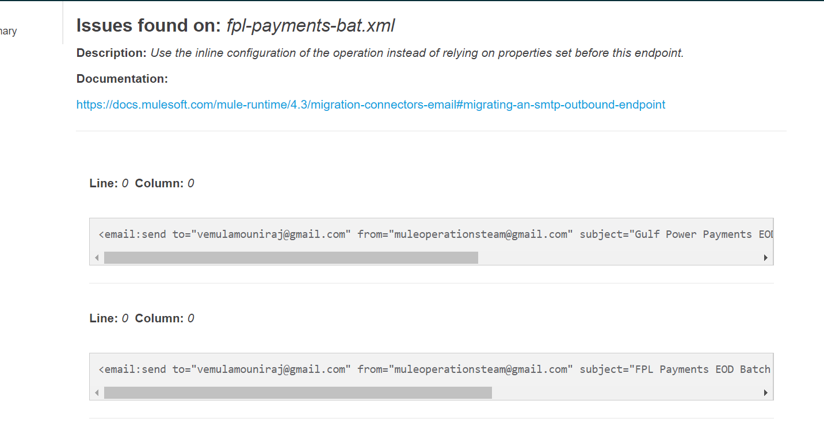

As per the code we need to make adjustments on SMTP Connector.

Once all necessary changes completed deploy and test the application.

* We are trying to convert mule 3.9.4 project into mule 4.2.0
* Need mule 3 Project folder file system location.
* Command Executed

java -jar mule-migration-assistant-runner-1.0.0.jar -muleVersion 4.2.0 -projectBasePath C:\Users\rajenvem\Desktop\Praveen\Mule3\moc-fpl-gp-batch-file-process-api -destinationProjectBasePath C:\Users\rajenvem\Desktop\Praveen\Mule4.2\moc-fpl-gp-batch-file-process-api

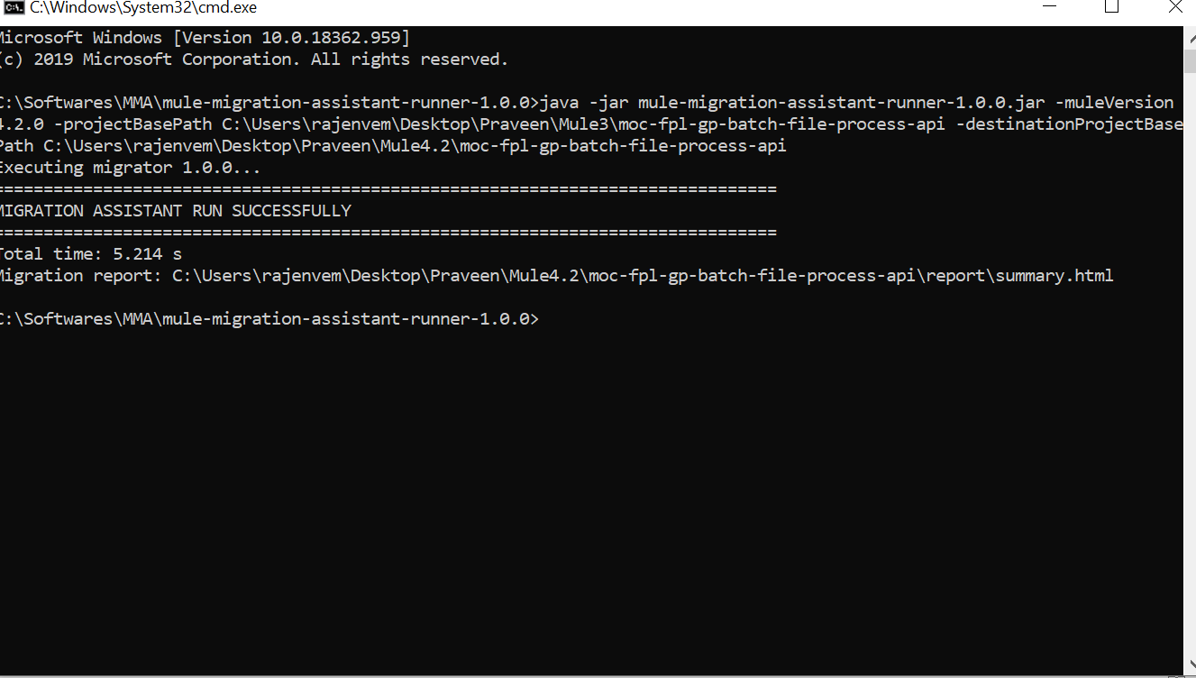

* Migrated projected will be saved to destinationProjectBasePath
* Navigate to migrated project location 🡪 report🡪 summary.html

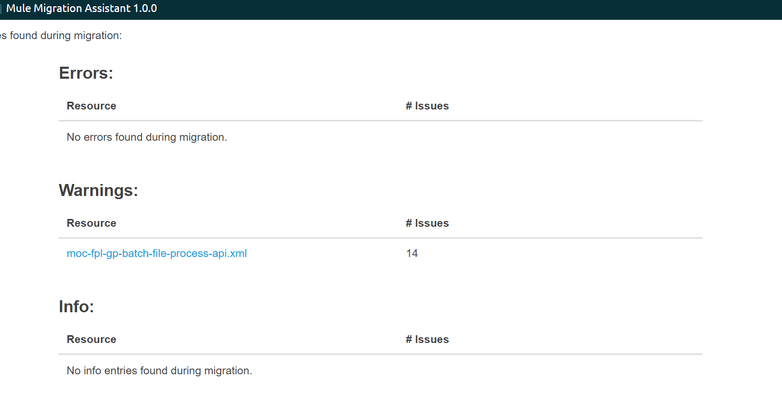

As per this all migration is done successfully

Import the project and test it .